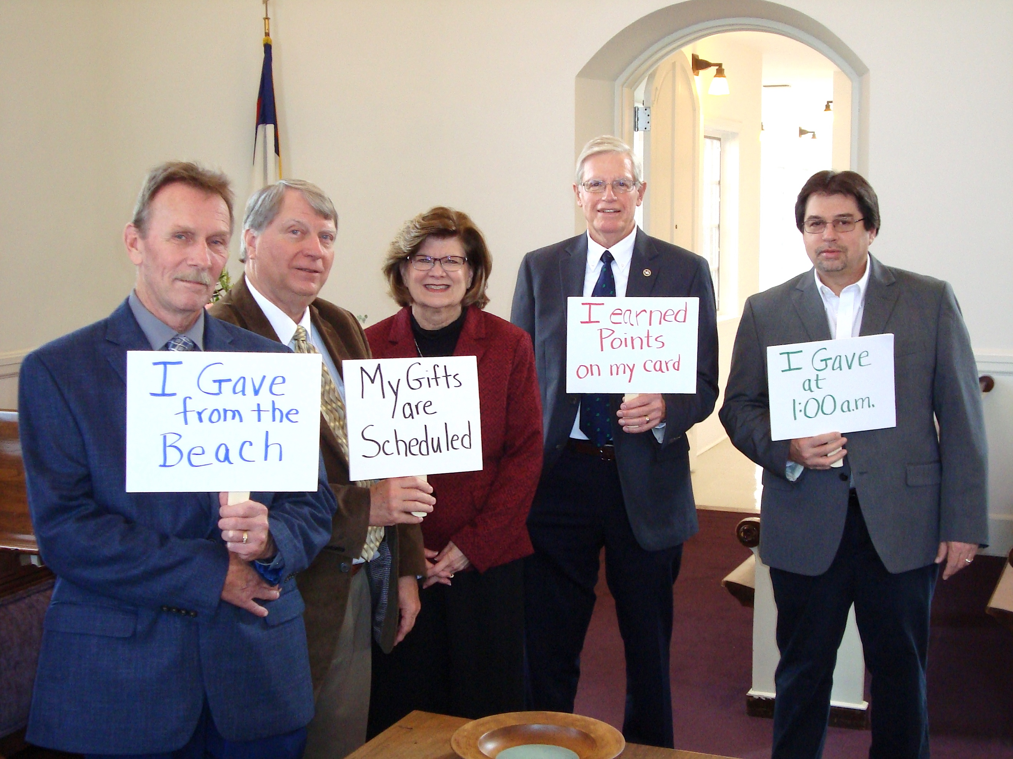
Leaders at Bethania Moravian Church, established in 1760, were early adopters of the Moravian Giving Portal. Left to right: Darrel Flippin, Dennis Ford, Interim Pastor The Rev. Judy Knopf, Trustee Chair Henry Gough, Tony Craddock.

Moravian Giving Portal helps donors connect with congregations, agencies, and ministries

By Vince Holbrook

“We noticed less than 25% of Moravian congregations had online giving enabled on their websites,” said Chris Spaugh, president and CEO of the Moravian Ministries Foundation in America (MMFA). “The priority, local talent, and infrastructure of using technology varies widely among congregations and ministries. We thought we could help,” Spaugh said.
Chris Spaugh
On August 1, 2019 The Moravian Ministries Foundation in America (MMFA) launched the Moravian Giving Portal on their own website, www.mmfa.info.
Many Moravian congregations who invest in the Moravian Common Fund gained the infrastructure to accept online credit card gifts for the first time. Donors got a single place to come to make multiple gifts to multiple agencies, ministries and congregations.

The Power of Moravian Community

“Moravians have long been famous for their ability to work together collaboratively. The Giving Portal is respectful of the Moravian communal heritage in that it creates a shared, central infrastructure for charitable giving – just as the Common Fund does for investing,” Spaugh said.

Justin Rabbach, executive director of the Moravian Board of World Mission and a member of Ebenezer Moravian Church in Wisconsin, can fully appreciate the convenience of a centralized Giving Portal.

“Being involved in a variety of Moravian ministries (missions, camps, congregation), I have a lot of things I would like to support. The Giving Portal allowed me to easily set up a regular gift which will go to support ministry, even when my travel schedule keeps me away physically,” Rabbach said.

Dunham & Company found that digital donors are up to eight times more likely to give to multiple funds (general, building, missions, music, etc.) vs. a donor who gives by cash or check. In 2017 three out of four churches offered a way to give online. This represents a 42% increase over the number of churches who offered online giving in 2015.
As it turns out, scheduled online giving is more reliable and more generous for a number of reasons. According to the National Study of Congregations’ Economic Practices 2019 (https://www.nscep.org), online giving accounts for 9.6% of total gifts in a church setting vs. 8.5% with other types of charity. And the average online gift to a church is $195 vs. $147 to other types of charity.
More and more people are using electronic banking to make all their financial payments, often on the day after payday. If congregants feel they need to wait until Sunday to physically place their gifts into the offering plate, they may be giving from their leftovers instead of their first fruits as a product of habit rather than intent. Churches benefit when members view their pledge with the same sense of priority they afford their other financial obligations.
Outreach: More and more congregations live stream services to a remote audience who may be inclined to give financially if you make it easy for them to do so online. Many people who grew up Moravian may still feel a strong connection to your church – even if they have moved away. Reaching out to associate members can help them stay in touch emotionally and stay invested financially.
Many congregations also have members who travel. “I like how the technology lets me make a consistent gift that my congregation can count on and use that information to plan ahead,” Rabbach said.

Recovery: Studies show when churches cancel services due to weather, they never fully recover the offerings they would have received on those days. Putting a link to your Giving Portal online giving form from your own web page, in your electronic newsletters, and social media, increase the odds of recovery.
Memorials in lieu of flowers: When beloved members of the congregation enter the more immediate presence of the Lord, others want to do something to honor and remember them. Offering a link to make online gifts to the church in lieu of flowers a part of the family and church communication helps everyone near and far do something meaningful and long-lasting. The same is true for honoring the living on occasions such as Mother’s Day and Father’s Day.
Early Success

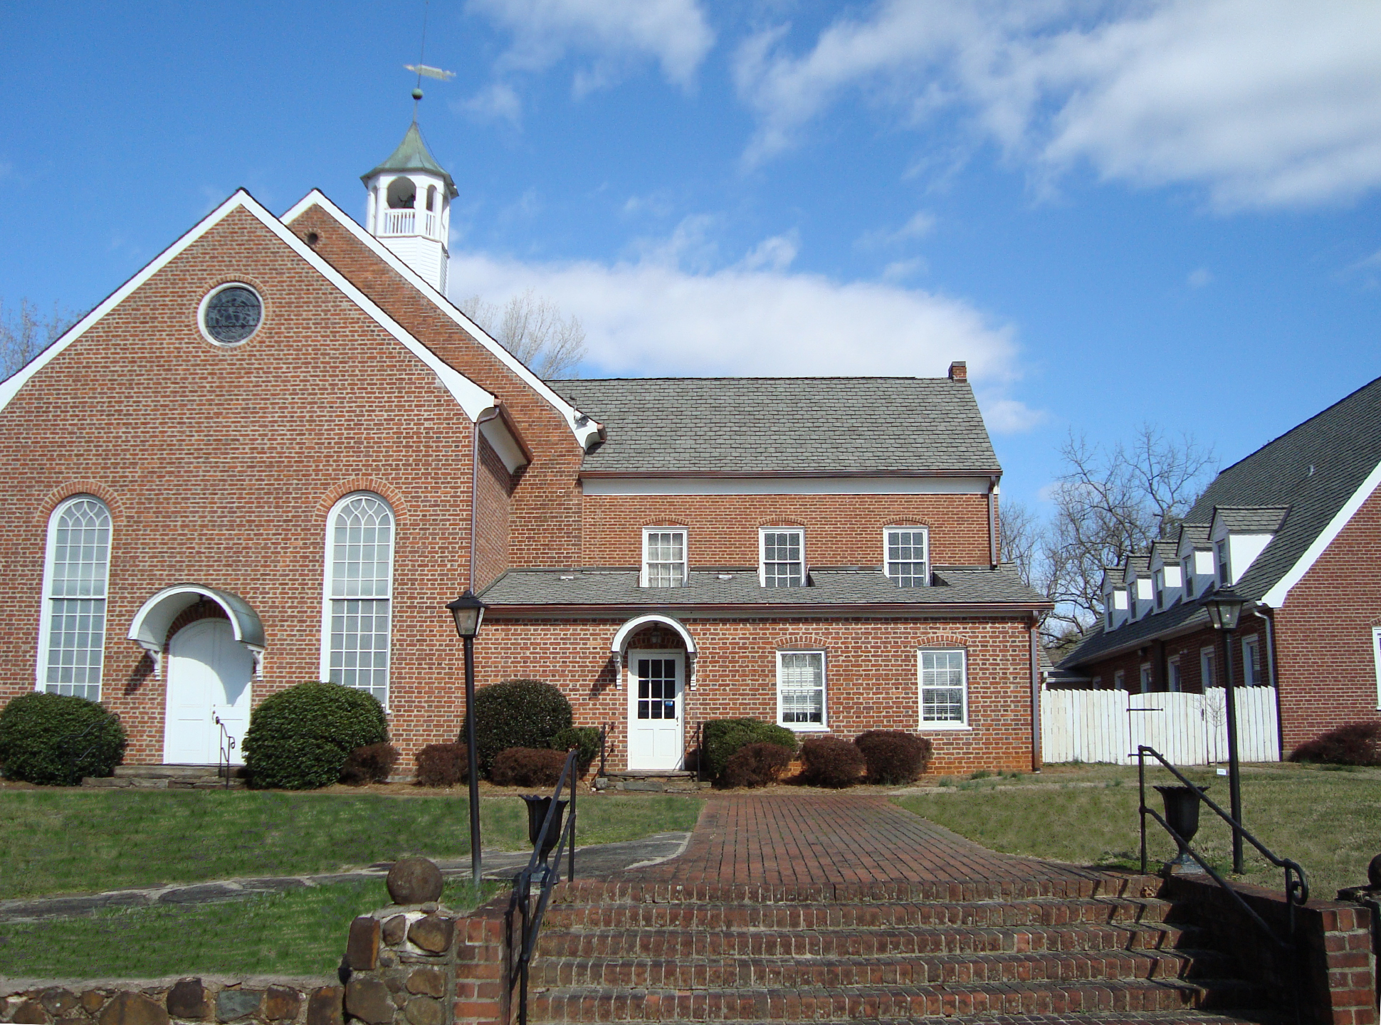
In December 2019 alone, the Giving Portal helped 37 donors make 56 gifts to 20 different entities, totaling more than $12,400, according to MMFA Director of Operations Kara Yates.

Bethania Moravian Church in Bethania, NC was among the first to embrace the Giving Portal in August 2019. More than one quarter of all donations through the Giving Portal in the last five months of 2019 were designated for Bethania Moravian Church. Sixteen donations, totaling $5,214, came through the Portal.
Bethania Moravian Church, Bethania, NC

Chairman of the Board of Trustees for Bethania Moravian Church Henry Gough said, “From the time our Board of Trustees was introduced to online giving we were very optimistic that this could be a benefit to our congregation. Many people now use this type of service to purchase a wide variety of goods and services, so why not use it for the benefit of our congregation?”
“We believed that the convenience factor would be very attractive to a large portion of our membership,” Gough added. “It’s not only a convenience to our regularly attending members, but also to members and associate members who no longer live in our area.”
How did they do it?

- They posted a link to the Giving Portal from their own website.
- They encouraged “first fruits” giving (scheduled monthly gifts)
- Representatives from the Board visited MMFA to ask questions and provide input.
- Board members led by example, making gifts through the Portal.
- Members discussed and questioned on the church’s social media.

Bethania Moravian Church received more gifts than any other during the Moravian Day of Service and Giving Tuesday. One of the five gift card winners during December was a donor from Bethania Moravian Church. One of the early “first fruit" (scheduled, monthly) givers also emerged from Bethania.

Member Scott Rainey said, “In the past, my wife and I have always struggled to remember and bring cash or a check on Sunday mornings. For years, we searched for something to make giving to our church more regular and convenient. When we heard about the Giving Portal, we were eager to set up monthly giving to avoid our continued forgetfulness. “

“Much like online bill payments, the Giving Portal gives us the freedom to know that our financial stewardship is a consistent part of our monthly expenses and our church's income,” he added.
Scott Rainey

Member George Pingho likes the Giving Portal because he can earn frequent flyer miles by making gifts on his card and can make the gifts at 1:00 a.m. if he wants.
If your Moravian congregation is among those who do not have online giving through the Moravian Giving Portal, please contact Chris Spaugh at 888-722-7923 or cspaugh@mmfa.info.

Logistically Simple

Providing the infrastructure and security for credit card payments online does have a cost. The processor for the Moravian Giving Portal is Blackbaud, one of the largest and most secure platforms. Here’s what they say about fees as of 1/8/2020:
- Credit Card/Bank Card Processing (Visa, MasterCard, Discover, American Express, JCB) 2.798% + $0.26 per transaction (US Dollars)
- ACH/Direct Debit: $0.75 per transaction (US Dollars)
For example, a $100 donation made via credit card would net $96.94 to the church/agency and a $3.06 fee to Blackbaud Merchant. A $100 donation via direct debit would net $99.25 to the church/agency and $0.75 to Blackbaud Merchant.
The infrastructure to use these Blackbaud Merchant Services (BBMS) is available through the Moravian Ministries Foundation in America because they purchase Blackbaud products. 100% of the processing fee goes to Blackbaud for their services. The Moravian Ministries Foundation gets no portion of this processing fee.
The fees for this service are actually deducted from the gifts. The receipt provided to the donor by the Giving Portal is for the full amount of his or her gift. The donor can use this receipt for tax purposes. The remainder of the gift goes to the church or agency.

The Moravian Ministries Foundation in America processes donations on a daily basis. However, to allow time for monthly reconciliations, and to allow donations to accumulate over a couple of weeks, the Foundation sends out distribution checks to the churches on a monthly basis.

For example, all gifts made in January, will be mailed to churches in February with a cover letter detailing who made which gifts, for what purpose, and a detail of any fees charged by Blackbaud Merchant.

Churches receive a detailed listing of donors and giving amounts with each monthly distribution check. The Donation Forms on the Moravian Giving Portal do allow donors to give anonymously. Unless a donor checks the box to mark the gift as anonymous, he or she will be identified on these reports.

But, don’t put your offering plates away. Some donors will always prefer the physical act of putting something in the offering plate. Some will prefer to make scheduled payments through their bank’s online services. Some Americans do not have checking accounts or credit cards. The Giving Portal is a tool to help congregations, agencies, and ministries accommodate the ever-changing preferences of new and existing donors. For more information, ask for Frequently Asked Questions, or contact Chris Spaugh at 888-722-7923, cspaugh@mmfa.info.

